Department of Computer Science and Engineering (Data Science)
CSDS-A | Batch A9 (CSE - Data Science, Section A)
Privacy-Preserving Machine Unlearning in Federated LLMs: A Certified Right-to-Be-Forgotten Framework
(ForgetSafe)
S.No. | Student name | Roll / hall ticket no.
1 | G.SHASHANK | 23K91A6761
2 | B.SATHISH | 23K91A6719
3 | G.RAKESH | 23K91A6759
4 | B.AKHIL | 23K91A6721
Under the guidance of: [GUIDE NAME], [DESIGNATION]
BLOCK DIAGRAMS
This document collects every design diagram of ForgetSafe. Each diagram was drawn from the real code (certified_unlearning/, app.py, frontend/src) and is followed by a paragraph that explains it. The diagrams were generated by scripts/make_diagrams.py with matplotlib.
Table 1: Diagrams in this document
No. | Diagram | Shows
1 | System architecture | Browser, React UI, standard-library API, engine, model, audit ledger and the alternative front doors
2 | High-level workflow | Train, request unlearning, subtract, verify, certify, record, audit
3 | DFD level 0 | Context: ForgetSafe and its external entities
4 | DFD level 1 | The main processes and data stores
5 | DFD level 2 | Expansion of the unlearning and certification processes
6 | Use-case diagram | Actors and their use cases
7 | Sequence diagram | Training, unlearning and audit verification across UI, API, engine and ledger
8 | ER diagram | The data model (there is no SQL database)
9 | UML class diagram | Engine, model, ledger, certificate and web classes
10 | Algorithm flowchart | Control flow of the unlearn() operation

1 System Architecture
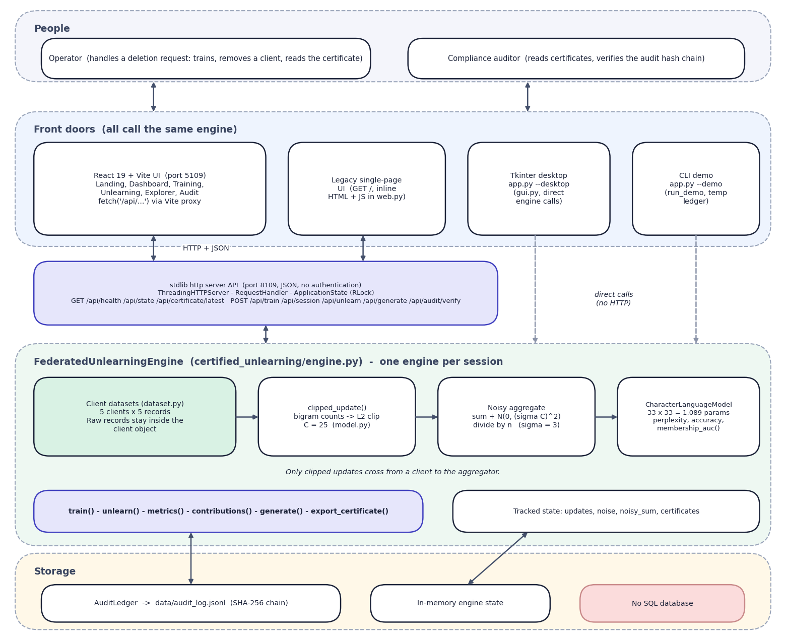
Fig. 1: System architecture of ForgetSafe
The diagram has five bands. At the top are the two kinds of person who use the system: the operator, who handles a deletion request by training, removing a client and reading the certificate, and the compliance auditor, who reads certificates and verifies the audit chain. Below them are four front doors that all call the same engine: the React web application on port 5109, which reaches the Python server through the Vite proxy with HTTP and JSON; the original single-page interface that the Python server returns at /; the Tkinter desktop window started with python app.py --desktop; and the terminal demonstration started with --demo. The last two call the engine directly (dashed arrows).
The third band is the standard-library API on port 8109 (ThreadingHTTPServer, the request handler and ApplicationState with its re-entrant lock; JSON, no authentication), and the figure lists the nine routes it serves. The fourth band is the FederatedUnlearningEngine, one per session. Inside it the client datasets, the clipped-update step, the noisy aggregate and the character language model form a left-to-right chain, a note states that only clipped updates cross from client to aggregator, and the engine's operations (train, unlearn, metrics, contributions, generate, export_certificate) and tracked state (updates, noise, noisy sum, certificates) sit below the chain. The bottom band is storage: the hash-chained ledger file, the in-memory engine state, and an explicit 'No SQL database' box.

2 High-Level Workflow
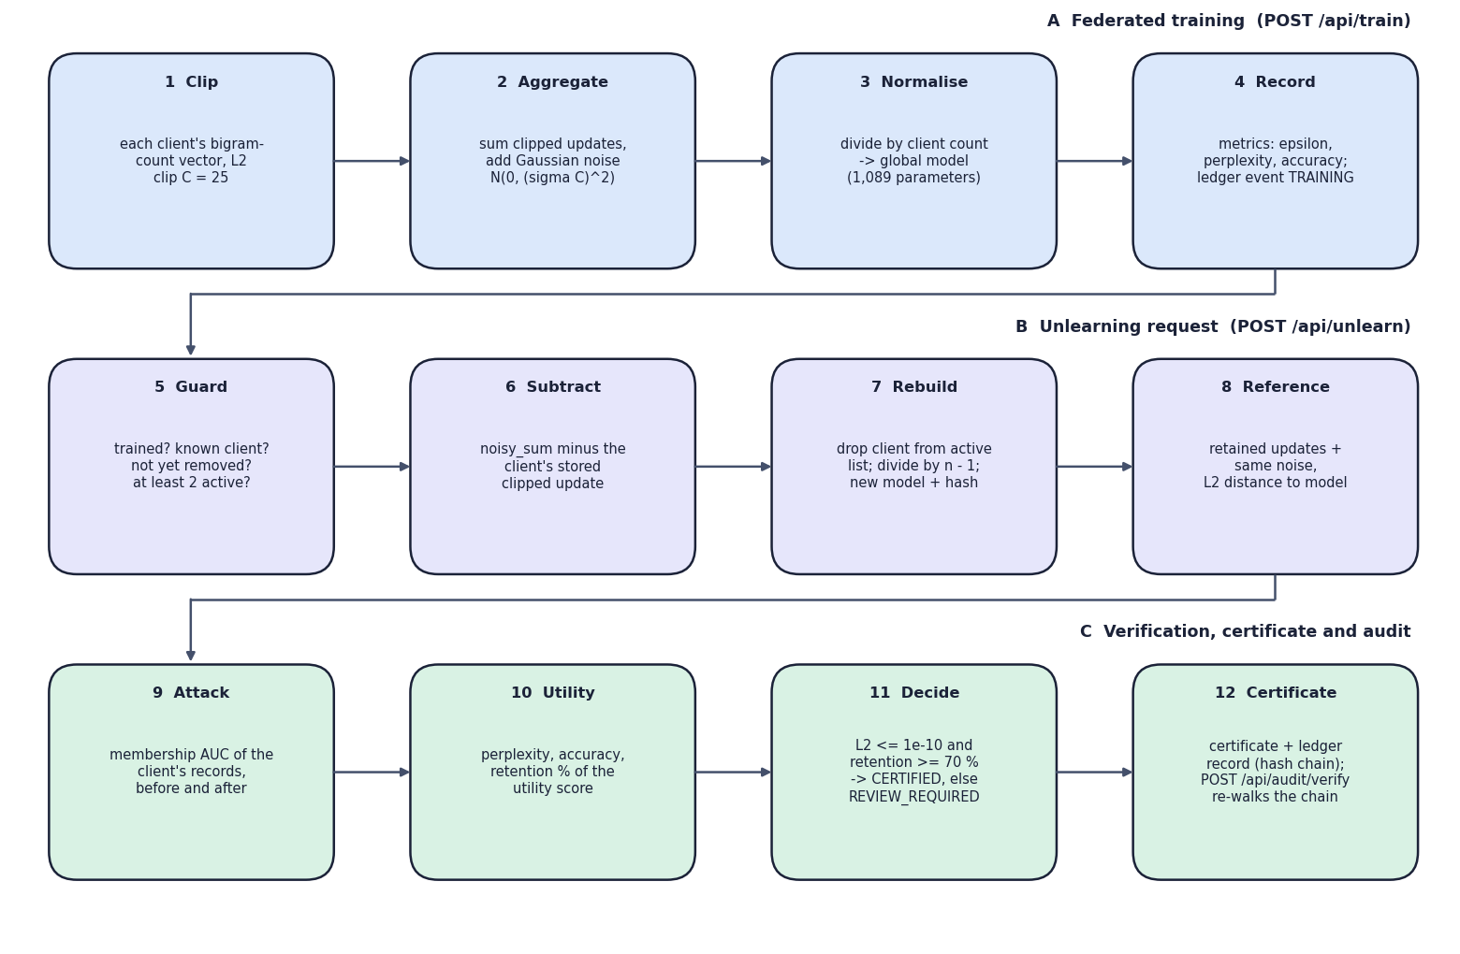
Fig. 2: High-level workflow of a training and an unlearning request
The workflow has twelve steps in three bands. Band A is federated training (POST /api/train): clip each client's bigram-count vector at C = 25, sum the clipped updates and add Gaussian noise, divide by the client count to obtain the 1,089-parameter global model, and record the metrics and a training event in the ledger. Band B is the unlearning request (POST /api/unlearn): check the guards, subtract the client's stored update from the noisy sum, drop the client from the active list and rebuild the model with a new hash, and recompute the retained-only reference and its L2 distance to the model. Band C is verification, certificate and audit: the membership AUC of the client's records before and after, the perplexity, accuracy and retention of the utility score, the decision CERTIFIED when the distance is at most 1e-10 and the retention at least 70 percent (otherwise REVIEW_REQUIRED), and the certificate with its ledger record, which POST /api/audit/verify can re-walk at any time.

3 Data-Flow Diagram: Level 0
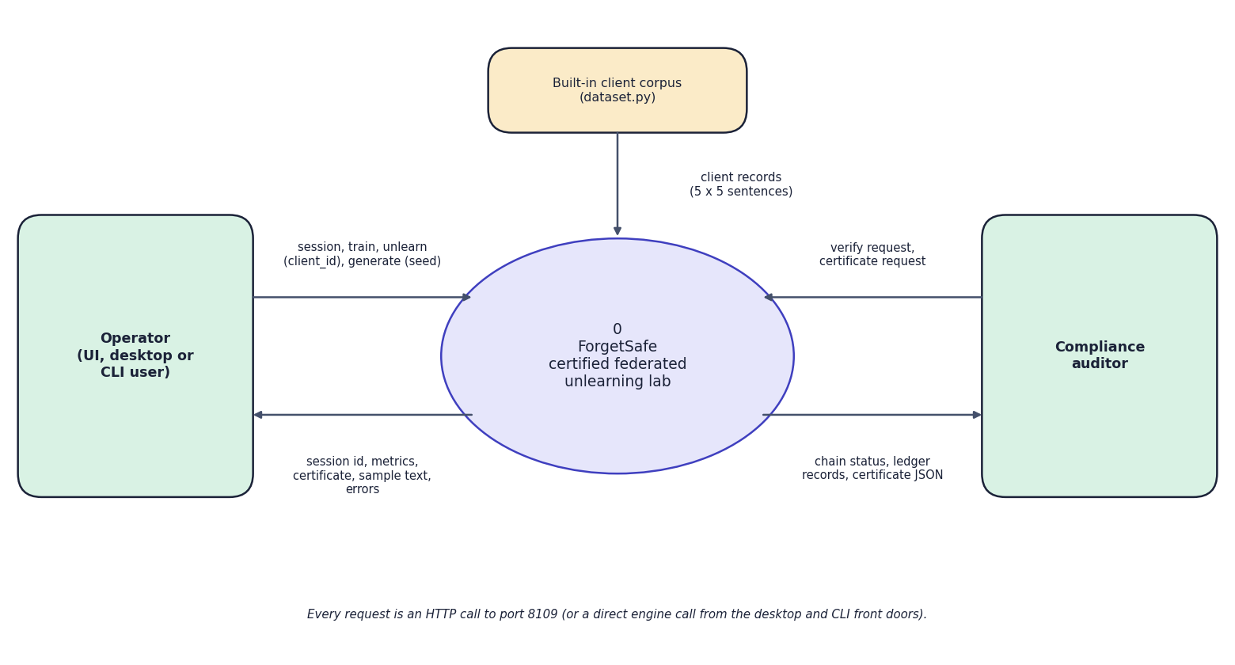
Fig. 3: Data-flow diagram, level 0 (context)
At the highest level ForgetSafe is one process, drawn as the circle labelled 0, with three external entities. The operator (a person using the web interface, the desktop window or the command-line demonstration) sends session and train requests, the client id to remove and a seed text, and receives the session id, the metrics (epsilon, perplexity, accuracy), the certificate as JSON, sample text and error messages. The compliance auditor sends verification and certificate requests and receives the chain status, the ledger records and the certificate JSON. The built-in client corpus in dataset.py (25 sentences) is the only data source and flows into the system. The note at the bottom states that every request is an HTTP call to port 8109 or a direct engine call from the desktop and command-line front doors; there is no database server, model hub or message queue.

4 Data-Flow Diagram: Level 1
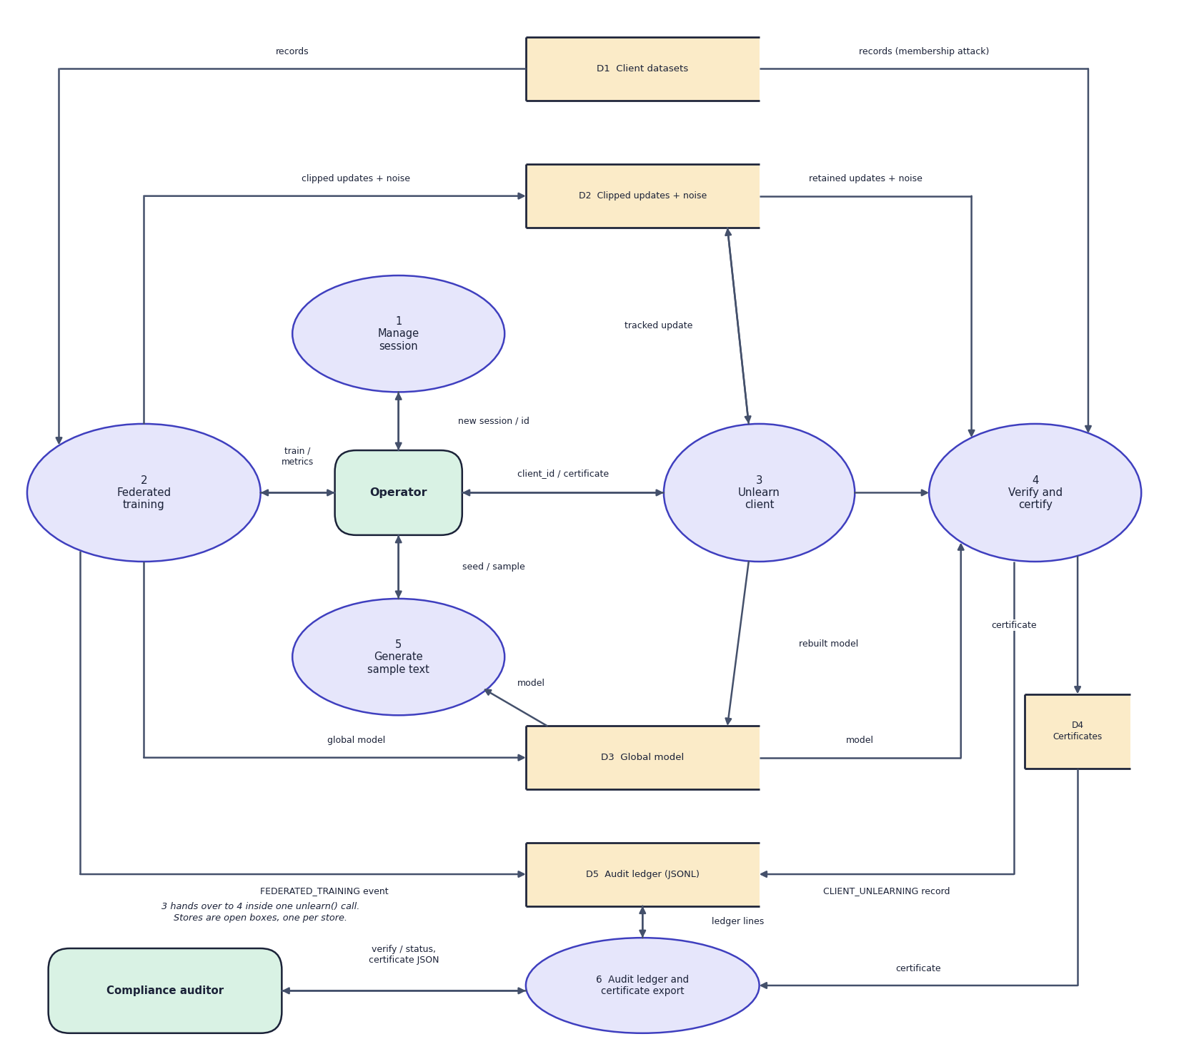
Fig. 4: Data-flow diagram, level 1
Level 1 divides the system into six processes: manage session (1), federated training (2), unlearn client (3), verify and certify (4), generate sample text (5), and audit ledger and certificate export (6). Five data stores appear as open boxes: the client datasets (D1, drawn twice to keep the arrows short), the clipped updates with the stored noise (D2), the global model (D3), the certificates held in memory (D4) and the audit ledger file (D5). Training reads D1 and writes D2 and D3; unlearning reads and rewrites D2 and D3; verification reads D1, D2 and D3 and writes D4 and D5; sample generation reads D3; and process 6 reads and writes the ledger and reads the certificates. D5 is the only store that survives a restart.

5 Data-Flow Diagram: Level 2
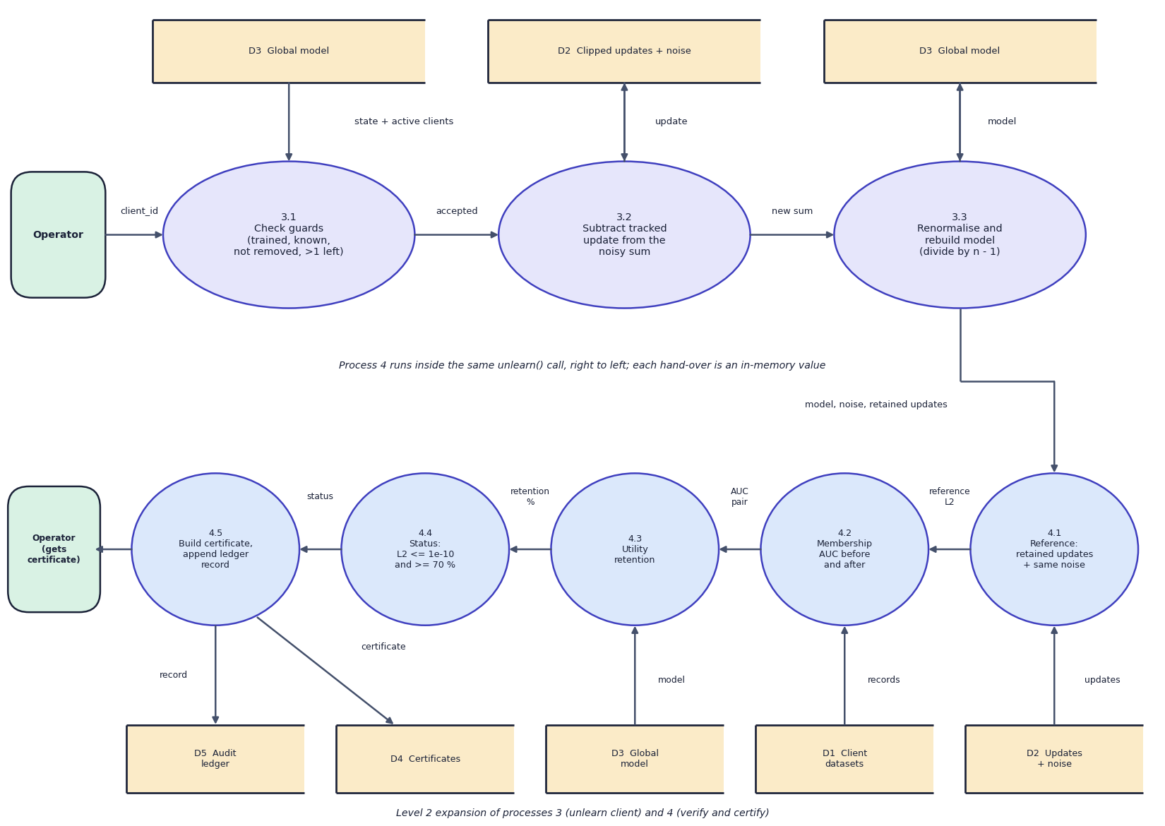
Fig. 5: Data-flow diagram, level 2 (unlearning and verification)
Level 2 expands the two processes that carry the contribution of the project. Unlearning (3) has three sub-processes: 3.1 checks the guards (trained, known client, not yet removed, more than one client left) against the model and the active clients, 3.2 subtracts the tracked update held in D2 from the noisy sum, and 3.3 renormalises, rebuilds the model and stores it in D3. Verification (4) runs, drawn right to left in the lower band, as five sub-processes inside the same unlearn() call: 4.1 builds the retained-only reference from the updates and the same noise and measures its distance to the model, 4.2 measures the membership AUC from the client records (D1) before and after, 4.3 computes the utility retention from the model, 4.4 decides the status, and 4.5 builds the certificate, stores it in D4 and appends the ledger record to D5. The operator receives the certificate.

6 Use-Case Diagram
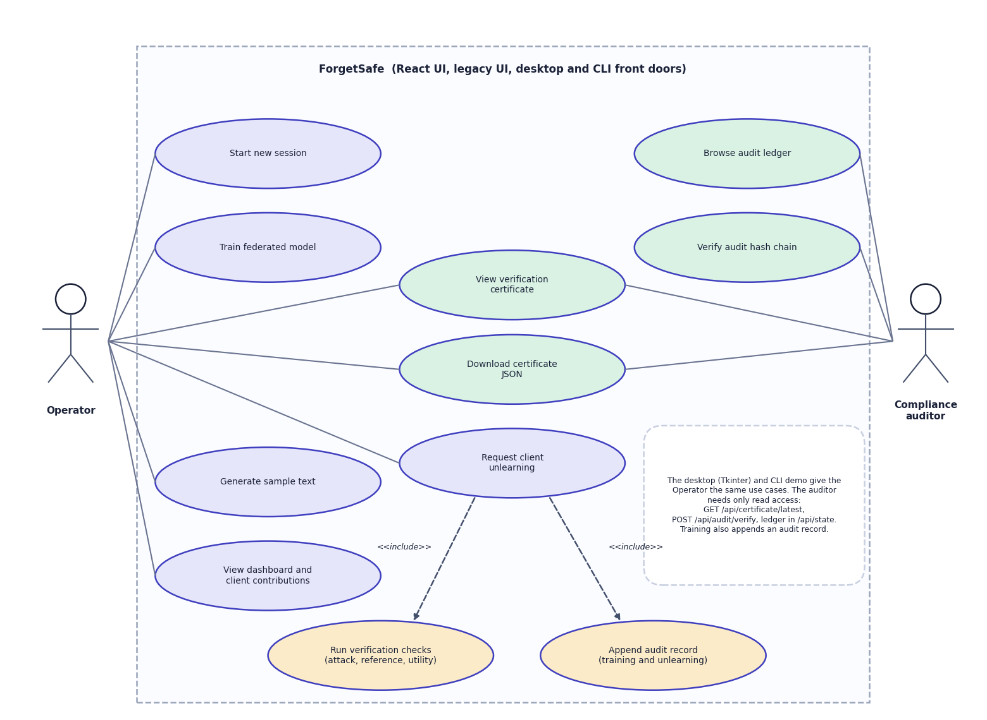
Fig. 6: Use-case diagram
Two actors use the system, which the frame labels as the React UI, the legacy UI and the desktop and command-line front doors. The operator starts a new session, trains the federated model, generates sample text, views the dashboard and the client contributions, and requests the unlearning of a client. That last use case includes two others, drawn with dashed include arrows: running the verification checks (attack, reference, utility) and appending an audit record for both training and unlearning events. The compliance auditor browses the audit ledger and verifies the hash chain. Viewing a verification certificate and downloading it as JSON are shared by both actors. A note on the diagram records that the desktop and command-line interfaces expose the same use cases to the operator and that the auditor needs only read access (GET /api/certificate/latest, POST /api/audit/verify, the ledger in /api/state). The diagram contains no login or role use case because the application has no authentication; that absence is recorded as a limitation of the system.

7 Sequence Diagram
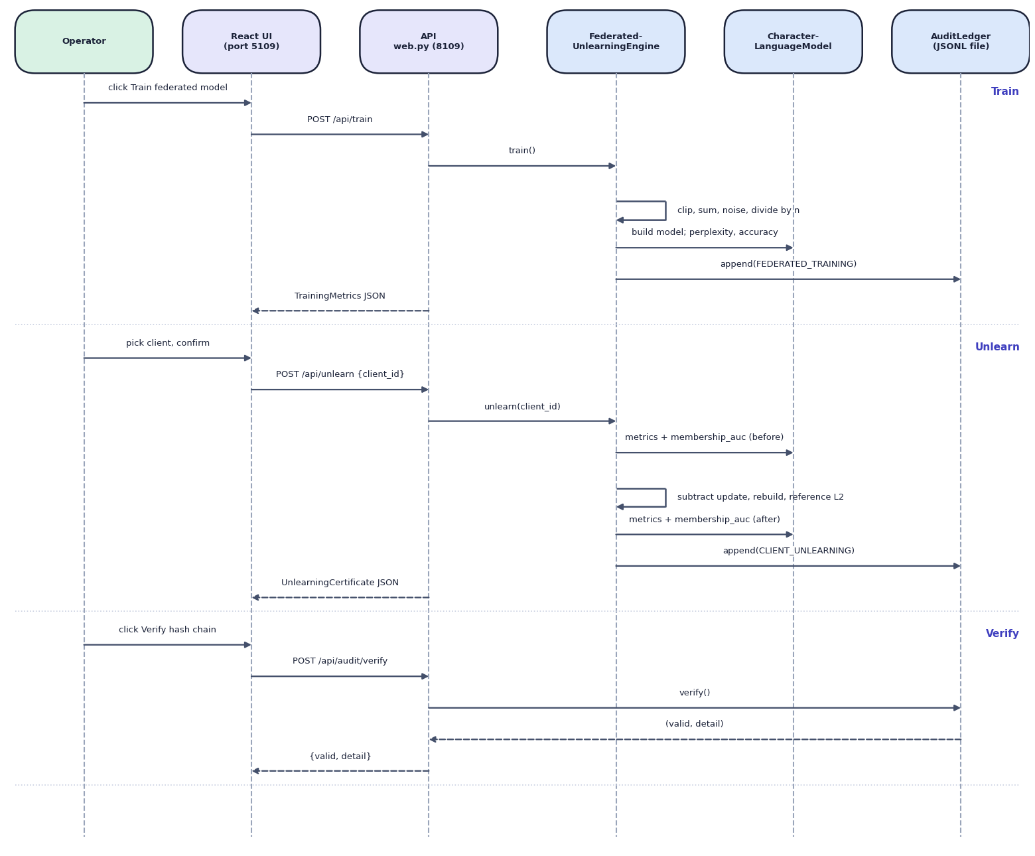
Fig. 7: Sequence diagram of training, unlearning and audit verification
Six lifelines run left to right: the operator, the React UI (port 5109), the API in web.py (port 8109), the engine, the character language model and the audit ledger. The Train band shows the operator pressing Train, the UI calling POST /api/train, the API calling train(), the engine clipping, summing, adding noise and dividing by n, asking the model for perplexity and accuracy, appending the FEDERATED_TRAINING event and returning the metrics JSON. In the Unlearn band the operator picks a client and confirms, the UI calls POST /api/unlearn with the client id, and the engine asks the model for metrics and the membership AUC before, subtracts the update and rebuilds, asks again after, appends CLIENT_UNLEARNING and returns the certificate JSON. In the Verify band the Verify button calls POST /api/audit/verify, the API calls the ledger's verify() directly, and the pair (valid, detail) returns as {valid, detail}.

8 Entity-Relationship Diagram
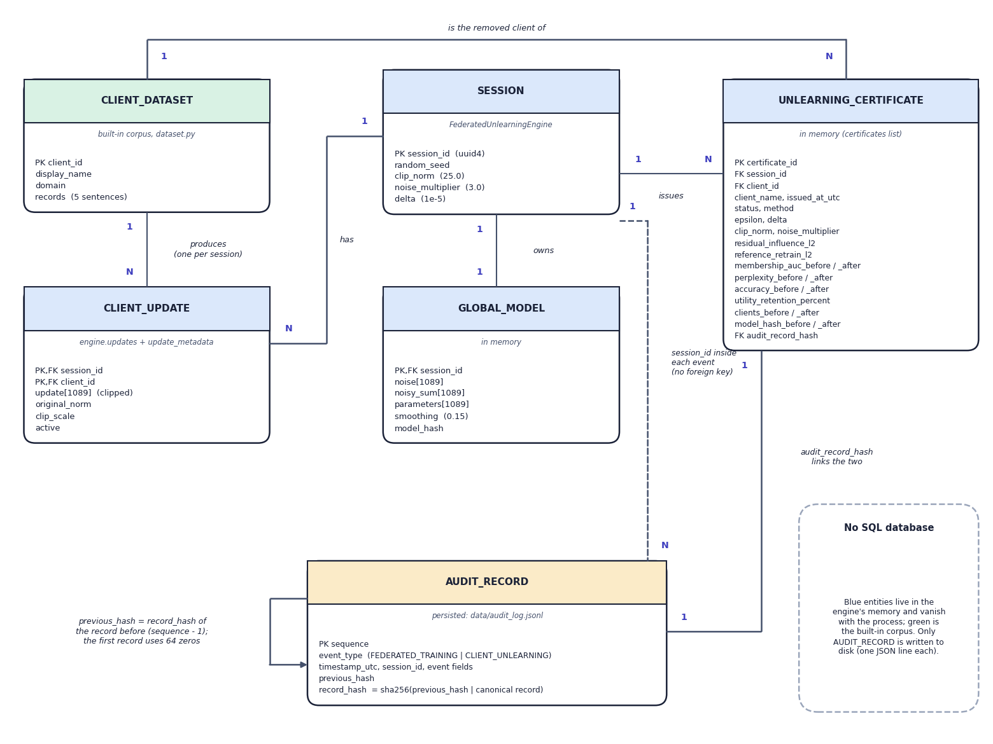
Fig. 8: Entity-relationship view of the data model (no SQL database)
ForgetSafe has no relational database, so the diagram shows the entities of its data model and how they relate; a note in the corner says so, and colour separates the in-memory entities (blue and green) from the persistent one (amber). A client dataset produces one client update per session, and a session has one update for each client, one global model (the noise, the noisy sum, the parameters and the model hash) and any number of certificates. Each certificate names the client dataset it removed and is linked one-to-one with an audit record through audit_record_hash. The audit record carries the session id inside its event fields but has no foreign key, and its previous_hash points to the record before it, the first record using 64 zeros, which is the self-link that forms the chain. Only the audit record is written to disk, as one JSON line of data/audit_log.jsonl.

9 UML Class Diagram
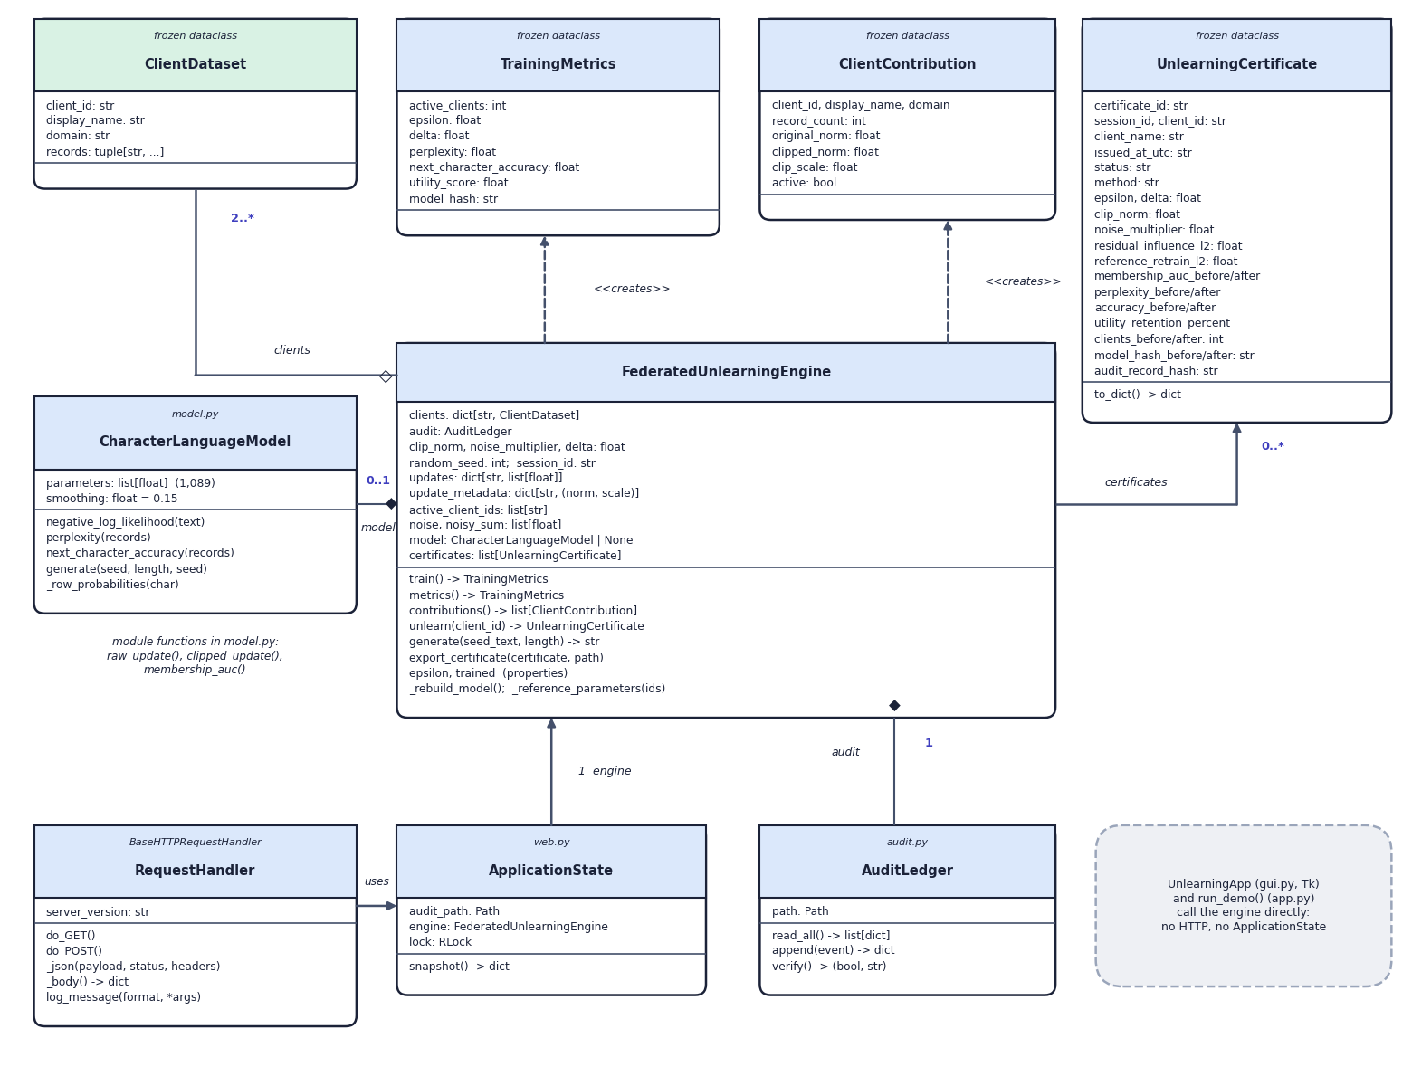
Fig. 9: UML class diagram
The class diagram shows the engine at the centre. FederatedUnlearningEngine aggregates two or more ClientDataset objects, holds at most one CharacterLanguageModel (composition, 0..1, because the engine starts untrained) and exactly one AuditLedger (composition), keeps zero or more UnlearningCertificate objects, and creates TrainingMetrics and ClientContribution values through dashed creates dependencies; all four value classes are frozen dataclasses. ApplicationState holds one engine and a re-entrant lock for the web layer, and the request handler built by make_handler uses it. A grey note states that the Tkinter class UnlearningApp and run_demo() call the engine directly, with no HTTP and no ApplicationState. The module-level functions of model.py (raw_update, clipped_update, membership_auc) are noted beside the model class.

10 Flowchart of the Core Algorithm
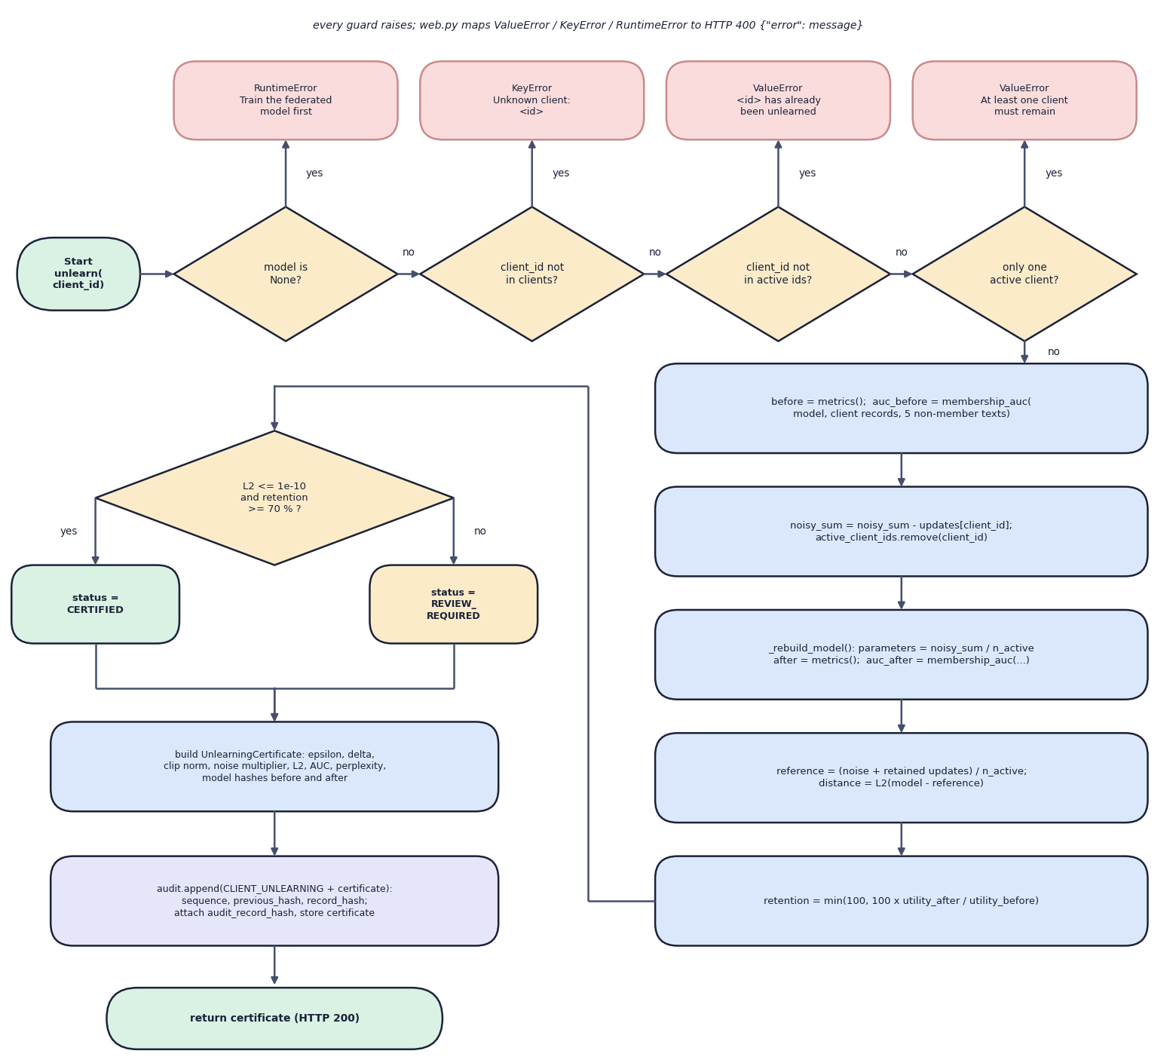
Fig. 10: Flowchart of the unlearning algorithm (`FederatedUnlearningEngine.unlearn`)
The flowchart follows unlearn() from the start terminal. Four diamonds are the guards: the model is untrained (RuntimeError), the client id is unknown (KeyError), the client has already been unlearned (ValueError), or only one client is active (ValueError); each 'yes' leaves through a red box and web.py maps all of them to HTTP 400. A request that passes records the metrics and the membership AUC, subtracts the tracked update and removes the client, rebuilds the model and measures again, recomputes the reference and its L2 distance, and computes the retention. The last diamond tests the distance against 1e-10 and the retention against 70 percent: both true gives CERTIFIED, otherwise REVIEW_REQUIRED. Either way the certificate is built, appended to the ledger and returned with HTTP 200.

